**Ten (10) SQL questions developed**

/* QUESTIONS */

/* Question 1: List customers ( first name and Last name) who spent 90 dollars */

SELECT CUSTOMERS_T.First_Name,CUSTOMERS_T.Last_Name

FROM CUSTOMERS_T INNER JOIN PAYMENT_T

ON CUSTOMERS_T.First_Name=PAYMENT_T.First_Name AND CUSTOMERS_T.Last_Name=PAYMENT_T.Last_Name

WHERE CUSTOMERS_T.Price=90;

/* Question 2: When was the delivery made for all the custumers? */

SELECT CUSTOMERS_T.First_Name, CUSTOMERS_T.Last_Name, DELIVERY_T.Date_Delivered

FROM CUSTOMERS_T LEFT OUTER JOIN DELIVERY_T

ON DELIVERY_T.Delivery_ID = CUSTOMERS_T.Customer_ID;

/* Question 3: What did every customers ordered? */

SELECT CUSTOMERS_T.First_Name, CUSTOMERS_T.Last_Name, CUSTOMER_ORDER_T.Product_Name

FROM CUSTOMERS_T LEFT OUTER JOIN CUSTOMER_ORDER_T

ON CUSTOMERS_T.Customer_ID = CUSTOMER_ORDER_T.Customer_ID;

/* Question 4: Who are the U.S.A. suppliers ? */

SELECT SUPPLIER_T.Name,SUPPLIER_T.Country

FROM SUPPLIER_T

WHERE SUPPLIER_T.Country='U.S.A.';

/* Question 5: What is the total cost of all the inventory items ordered to suppliers? */

SELECT SUM(total)

FROM ORDER_DETAILS;

/* Question 6: How much did each customers spent?*/

SELECT CUSTOMERS_T.First_Name,CUSTOMERS_T.Last_Name,CUSTOMERS_T.Price

FROM CUSTOMERS_T;

/* Question 7: What Black wigs do we have? */

SELECT INVENTORY_T.Product_Name,INVENTORY_T.Product_Color

FROM INVENTORY_T

WHERE INVENTORY_T.Product_Color='Black';

/* Question 8: How many Black wigs do we have? */

SELECT COUNT(*)

FROM INVENTORY_T

WHERE INVENTORY_T.Product_Color='Black';

/* Question 9: What are the 4/5 rates comments? */

SELECT SURVEY_T.SURVEY_ID, SURVEY_T.comments

FROM SURVEY_T

WHERE SURVEY_T.Rating='4/5';

/* Question 10: How much in total did th customers spent? */

SELECT SUM(price)

FROM CUSTOMERS_T;

**Screenshots of Questions answered**

Question 1: List customers ( first name and Last name) who spent 90 dollars

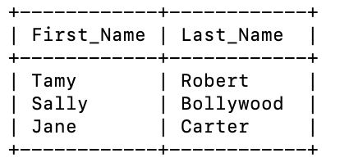

Question 2: When was the delivery made for all the custumers?

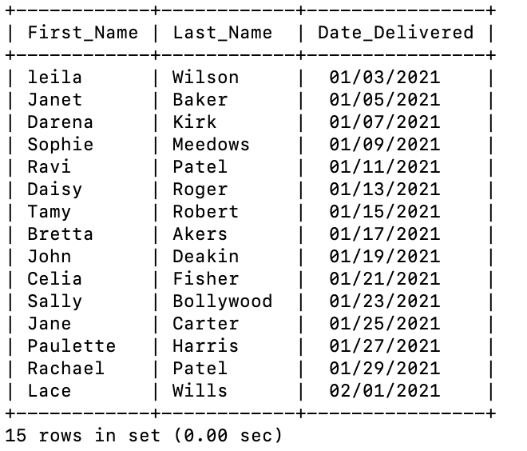

Question 3: What did every customers ordered?

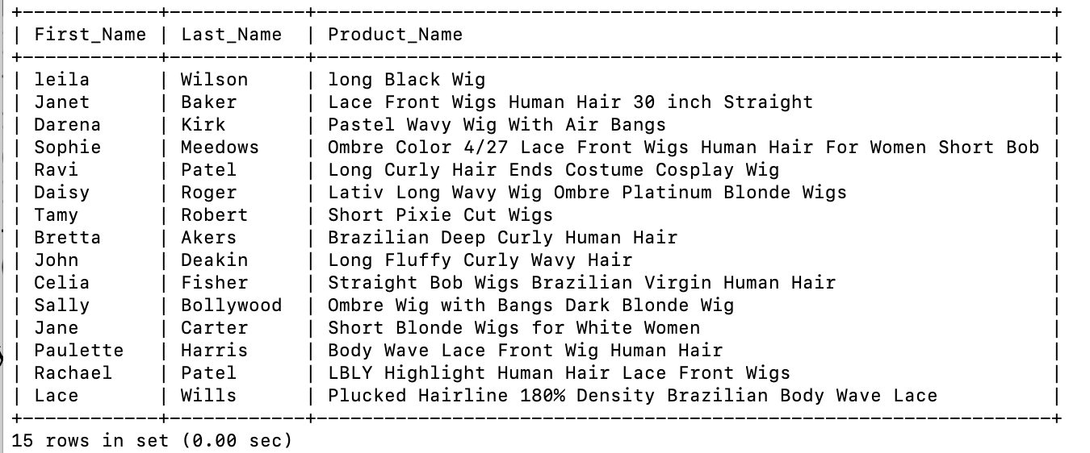

Question 4: Who are the U.S.A. suppliers ?

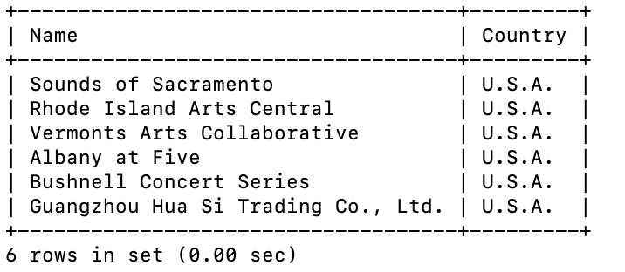

Question 5: What is the total cost of all the inventory items ordered to suppliers?

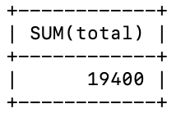

Question 6: How much did each customers spent?

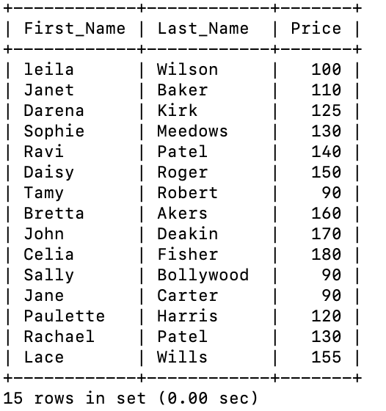

Question 7: What Black wigs do we have?

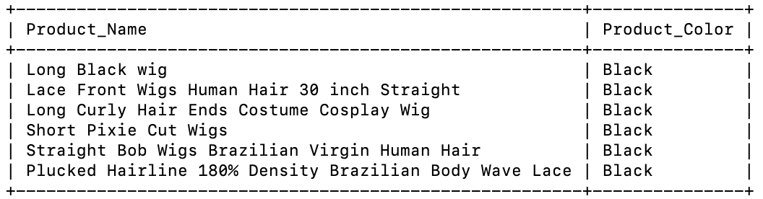

Question 8: How many Black wigs do we have?

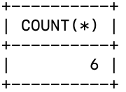

Question 9: What are the 4/5 rates comments?



Question 10: How much in total did the customers spent?

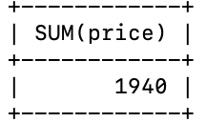

**Venn diagrams**

Question 1: List customers ( first name and Last name) who spent 90 dollars

Price

First_Name

Last_Name

Both

Payment_T

Customer_T

Question 2: When was the delivery made for all the costumers?

Date

Delivered

Delivery_ID

Customer_ID

First_Name

Last_Name

Both

Payment_T

Customers_T

Question 3: What did every customers ordered?

Both

Product_Name

Customer_ID

Customer_ID

First_Name

Last_Name

Customer_Order_T

Customer_T